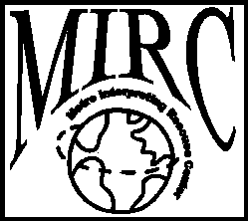 | Metro Interpreter Center  Ezzat Al Haidar, Coordinator  112 University Drive North  Fargo, ND 58102 Cell ph:  701-630-0676 Fax: 701-526-3001 E-mail: mirc@culturaldiversityresourcesorg

Interpreter Request Form
Hiring Agency Name:
Contact for this request: |  |  |  |  |  | Phone:
Billing Address:
Preferred gender of interpreter: |  |  |  |  | Male Female No preference
APPOINTMENT INFO
Appointment Date: |  |  | Appointment Time: |  |  |  | Appointment Length:
Facility Location (be specific):
Language/Dialect:
Other Preferences/ Specifications:
Notes:
Authorized Signature:
Your signature above indicates authorization to secure interpreting services and responsibility for payment on behalf of your company named above. Please fax Interpreter Request Form to 701-526-3001 or email at mirc@culturaldiversityresources.org
Requires one full business day notice to cancel an assignment; otherwise, payment in full is expected.
BILL FOR SERVICE
Date | Agency Staff Person |  |  | Hours:  @ $ /hour |  |  |  |  | Total : $
The services described herein were provided in a satisfactory manner. Billing for service can proceed.

01/11

